

REACT JS PROJECT REPORT ON
CERTIFICATE MANAGEMENT SYSTEM

Submitted by
MAHALAKSHMI R
24BIT027

Under the Guidance of
MR.ARAVINDH
Technical Trainer
Technical Department, KG College of Arts and Science

Academic Year: 2025 – 2026
APRIL 2026

DECLARATION
I hereby declare that the project entitled “CERTIFICATE MANAGEMENT SYSYTEM” submitted in partial fulfillment of the requirements for the course ReactJS is a record of my original work carried out under the guidance of Mr.Aravindh, Technical Trainer, Technical Department, KG College of Arts and Science.
I further declare that this project has not been submitted previously, either in part or in full, for the award of any degree, diploma, or other similar title, at this or any other institution.
I have acknowledged all sources of information used in this project wherever applicable.

April 2026
Coimbatore

R.Maha ________________________
(Your Name)

CERTIFICATE
This is to certify that the project entitled “PROJECT TITLE” is a bona fide work carried out by [YOUR NAME] [Class/Batch], [Department Name], KG College of Arts & Science, in partial fulfillment of the requirements for the course [Course Name].
This project has been completed under my supervision and guidance during the academic period April 2026.

Place:
Date:

Submitted for the Viva-Voce Examination held on __________________________________

Guide: Head of the Department
(Technical Trainer, KGCAS) (Technical Head, KGCAS)

______________________ _______________________

TABLE OF CONTENTS
S. No. | Topics | Page. No.
1 | Introduction
1.1 | Background of the Study
1.2 | Problem Statement
1.3 | Objectives of the Project
1.4 | Purpose and Significance
1.5 | Scope and Limitations
1.6 | Methodology Overview
2 | System Analysis
2.1 | Existing System
2.2 | Drawbacks of the Existing System
2.3 | Proposed System
2.4 | Features of the Proposed System
2.5 | Feasibility Study
2.6 | Requirement Analysis
3 | System Design
3.1 | System Architecture
3.2 | Use Case Diagram
3.3 | Data Flow Diagram (DFD)
3.4 | Entity Relationship Diagram (ERD)
3.5 | User Interface Design
4 | System Implementation
4.1 | Development Tools
4.2 | Module Description
4.3 | Algorithms
4.4 | System Integration
4.5 | Security and Validation
5 | System Testing
5.1 | Testing Methodology
5.2 | Test Cases
5.3 | Error Handling
5.4 | Performance
6 | Input and Output Screens
6.1 | System Outputs
6.2 | Discussion
6.3 | Comparison
6.4 | User Feedback
7 | Conclusion and Future Enhancement
7.1 | Summary
7.2 | Limitations
7.3 | Future Scope
8 | References
Appendices
- Source Code Snippets
- Screenshots of Web Pages

ABSTRACT

The Certificate Management System is a web-based application designed to simplify the process of storing, managing, and accessing certificate records in a digital environment. Traditional methods of handling certificates involve manual documentation, which can lead to data loss, duplication, and inefficiency. This system provides a structured and user-friendly platform where users can easily enter certificate details such as student name, course, date, and certificate ID. The application ensures organized data handling and quick retrieval of information.
The system is developed using React, a modern JavaScript library that enables efficient and dynamic user interface creation. It uses state management (useState) to store and manipulate data within the application. Users can add new certificates through input forms, view them in a tabular format, and delete unwanted records when necessary. The application focuses on simplicity, responsiveness, and ease of use, making it suitable for small-scale implementations such as educational institutions or training centers.
Although the current version operates without a backend database and stores data temporarily, it demonstrates the core functionality of a certificate management system. Future improvements can include database integration for permanent storage, user authentication for secure access, and additional features such as search, filter, and certificate upload/download options. Overall, this project highlights an efficient and scalable approach to digital certificate management using modern web technologies.

Chapter 1: Introduction
1.1 Background of the Study
The need for a Certificate Management System arises from the limitations of traditional record-keeping methods. Many institutions still rely on physical documents or basic spreadsheets to manage certificates, which are prone to errors, misplacement, and lack of security. As the number of records increases, it becomes difficult to maintain and track certificates efficiently.
With the advancement of web technologies, digital systems have become a preferred solution for data management. This study focuses on developing a simple yet effective certificate management application using React. The system demonstrates how modern web development tools can be used to create efficient, scalable, and user-friendly applications. It also highlights the importance of digitization in improving data accuracy, accessibility, and overall management efficiency.
1.2 Problem Statement
Many institutions still manage certificate records manually, leading to issues such as data loss, duplication, and difficulty in retrieval. Handling large amounts of data becomes time-consuming and inefficient, with higher chances of errors.
There is a lack of a centralized and automated system to manage certificates effectively. Therefore, a digital Certificate Management System is required to improve data organization, accuracy, and accessibility.
1.3 Objectives of the Project
- To develop a system for managing certificate records digitally
- To reduce manual work and avoid data errors
- To provide quick and easy access to certificate details
- To create a simple and user-friendly interface
1.4 Purpose and Significance of the Study
The purpose of this study is to develop a digital solution for efficiently managing certificate records. It aims to replace manual methods with an automated system that simplifies data entry, storage, and retrieval.The significance of this study lies in improving data accuracy, reducing paperwork, and saving time.
1.5 Scope and Limitations
Scope:
The system is designed to manage certificate records digitally by allowing users to add, view, and delete certificate details. It provides a simple interface for handling data efficiently and can be used in small-scale environments like colleges or training centers.
Limitations:
The system does not include a database, so data is not stored permanently. It lacks user authentication and advanced features like search, update, and file upload. It is currently limited to basic frontend functionality only.
窗体顶端
窗体底端
1.6 Methodology Overview
The project follows a simple development methodology using React for building the user interface. Initially, requirements were analyzed to identify key functionalities such as adding, viewing, and deleting certificate records. The system was then designed with a form-based input structure and a table for displaying data.
During implementation, React’s useState was used for managing data dynamically within the application. Functions were developed for handling user input, adding records, and deleting records. Finally, the system was tested to ensure proper functionality and smooth user interaction.

Chapter 2: System Analysis
2.1 Existing System
The existing system for managing certificates is mainly manual, using paper records or basic spreadsheets. This method is time-consuming and prone to errors such as data duplication, loss of records, and difficulty in searching specific information.
There is no proper centralized system, making it hard to maintain and update data efficiently. As the number of records increases, managing and retrieving certificate details becomes more complex and inefficient.
2.2 Drawbacks of the Existing System
· Prone to data loss and damage
· Time-consuming manual process
· Difficult to search and retrieve records
· High chances of data duplication and errors
· Lack of proper organization
· No centralized system for management
2.3 Proposed System
The proposed system is a web-based Certificate Management System developed using React. It provides a digital platform to efficiently store, manage, and retrieve certificate records. Users can easily add, view, and delete certificate details through a simple and user-friendly interface.
The system ensures better organization of data, reduces manual work, and improves accuracy. It offers a centralized solution for managing certificates, making the process faster, reliable, and more efficient compared to the existing manual system.
2.4 Features of the Proposed System
. Add new certificate records easily
· View all certificates in a structured table
· Delete unwanted or incorrect records
· Simple and user-friendly interface
· Fast performance using React
·
2.5 Feasibility Study
Technical Feasibility:
The project is developed using lightweight technologies like React, JavaScript, HTML, and CSS, ensuring easy development, fast performance, and cross-platform compatibility.
Economic Feasibility:
The development cost is minimal as it uses open-source tools and does not require any paid software or infrastructure for the prototype.
Operational Feasibility:
The system is simple and user-friendly, requiring no special training, making it easy for users to operate and adopt efficiently.
2.6 Requirement Analysis
Functional Requirements:
- Ability to add certificate details (name, course, date, ID)
- Display all certificates in a table format
- Delete certificate records when required
- Validate input fields before submission
Non-Functional Requirements:
- Simple and user-friendly interface
- Fast performance and responsiveness
- Easy navigation and usability
- Reliability in handling data without errors

Chapter 3: System Design
3.1 Introduction
System design is the process of defining the architecture, components, and structure of the application. It provides a clear blueprint for how the system will function and interact with users.
In this project, the system is designed using a simple frontend architecture with React. It includes input forms for data entry, state management for handling data, and a table layout for displaying certificate records. The design focuses on simplicity, efficiency, and ease of use.
3.2 System Architecture
The system follows a three-layer architecture — Presentation Layer (Frontend), Application Logic Layer, and Data Layer.

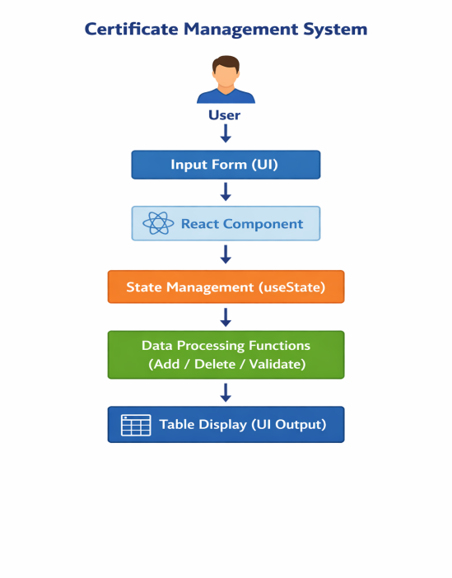
Description:
Presentation Layer:
Handles user interaction and displays the interface, including input forms and table output. Application Layer:
Processes user input and performs logic operations such as adding, deleting, and validating certificate data.
Data Layer:
Manages data storage using React state (useState), storing certificate details temporarily in structured format.
3.3 Use Case Diagram
1. What is a Use Case Diagram?
A Use Case Diagram visually represents how users interact with a system. It shows:
- Actors → Users who interact with the system
- Use Cases → Actions performed by the users
- Relationships → Connection between actors and actions
It helps to clearly explain “who does what” in the system.
2. Identify the Main Actors (for your Educational Website)
Actor | Description
Admin | Manages certificate records by adding, viewing, and deleting data in the system.
User (student) | Accesses the system to view certificate details and verify information.
System (Application) | Processes user inputs, manages data using state, and displays results accordingly.
3. Identify the Main Use Cases
For Student/User
· Add Certificate Details
· View Certificate Records
· Delete Certificate
· Verify Certificate Information
For Administrator
· Login to System
· Manage Certificates (Add / Delete)
· Monitor and View All Records
· Ensure data accuracy and maintenance
4. Define Relationships
Symbol | Meaning
Association (—) | Shows interaction between actor and use case
<<include>> | One use case always includes another
<<extend>> | Adds optional functionality to a use case
Example:
- “Attempt Quiz” <<include>> “Submit Quiz”
- “View Result” <<extend>> “Attempt Quiz”
5. Draw the Diagram (Structure Example)
Tools you can use:
- draw.io (free online)
- Lucidchart
- StarUML
- MS Visio
Admin User
| |
| |
└──────┬───────┘
↓
---------------------------
| Certificate Management |
| System |
|--------------------------|
| Add Certificate |
| View Certificates |
| Delete Certificate |
---------------------------

6. EXAMPLE EXPLANATION (TEXT DESCRIPTION)

Actors:
- User (Student): Interacts with the system to add, view, and manage certificate records.
- Administrator: Monitors and manages all certificate data in the system.
- System: Handles processing, validation, and display of certificate information.

Use Cases:
- Add Certificate: User enters certificate details into the system.
- View Certificates: User views all stored certificate records.
- Delete Certificate: User removes unwanted certificate data.
- Validate Data: System checks input fields before storing data.
- Display Data: System shows records in table format.
- Manage Records (Admin): Admin controls and maintains all certificate data.

Relationships:
- “Add Certificate” includes “Validate Data”.
- “View Certificates” includes “Display Data”.
- “Manage Records” includes “Add Certificate” and “Delete Certificate”.

7. STEP-BY-STEP (Using draw.io)
- Go to https://app.diagrams.net
- Create a new blank diagram → name it “Use Case Diagram”
- From the left panel, drag:
  - Stick figures → Actors (User, Admin)
  - Ovals → Use Cases
  - Rectangle → System Boundary (Certificate Management System)
- Place actors outside and use cases inside the box
- Connect actors to use cases using lines
- Add labels like <<include>> for relationships
- Export as PNG/JPG and insert into your document
3.4 Data Flow Diagram (DFD)

1. What is a Data Flow Diagram (DFD)?
A Data Flow Diagram (DFD) shows how data flows through a system — from input to processing, storage, and output.
It helps to visualize:
- Data Source → Where the data comes from (User)
- Processes → Operations performed on data (Add, Delete, Validate)
- Data Store → Where data is stored (React State)
- Output/Destination → Where data is displayed (Table/UI)
2. DFD Symbols You’ll Use
Symbol | Meaning
Rectangle | External Entity (e.g., User, Admin)
Circle / Rounded Rectangle | Process (e.g., “Certificate”, “Validate data”)
Two Parallel Lines | Data Store (e.g., “state”)
Arrow | Data Flow (shows direction of data movement)
3. Levels of DFD
Level 0 — Context Diagram:
Represents the entire Certificate Management System as a single process and shows interaction with external entities like User and Admin.
Level 1 — Decomposition:
Breaks the system into main processes such as Add Certificate, View Certificates, and Delete Certificate.
Level 2 — Detailed Level:
Further divides processes like validation, data handling, and display (optional for this project).

4. STEPS TO CREATE A DFD

Step 1: Identify External Entities
- User (Student)
- Administrator

Step 2: Identify Main Processes
- Add Certificate
- View Certificates
- Delete Certificate
- Validate Data
- Manage Records (Admin)

Step 3: Identify Data Stores
- Certificate Data Store (React State)

Step 4: Identify Data Flows
- “Enter Certificate Details”
- “Validated Data”
- “Stored Certificate Data”
- “Display Records”
- “Delete Request”
5. DFD for Educational Website
Level 0: Context Diagram
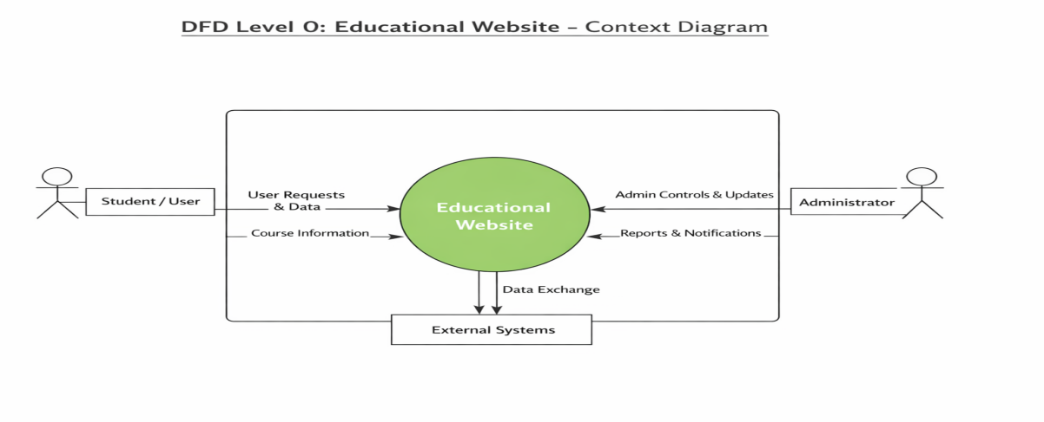
Explanation:
- Student interacts with the system to view courses, read lessons, and take quizzes.
- Admin updates and manages course and quiz content.
Level 1: Detailed System View
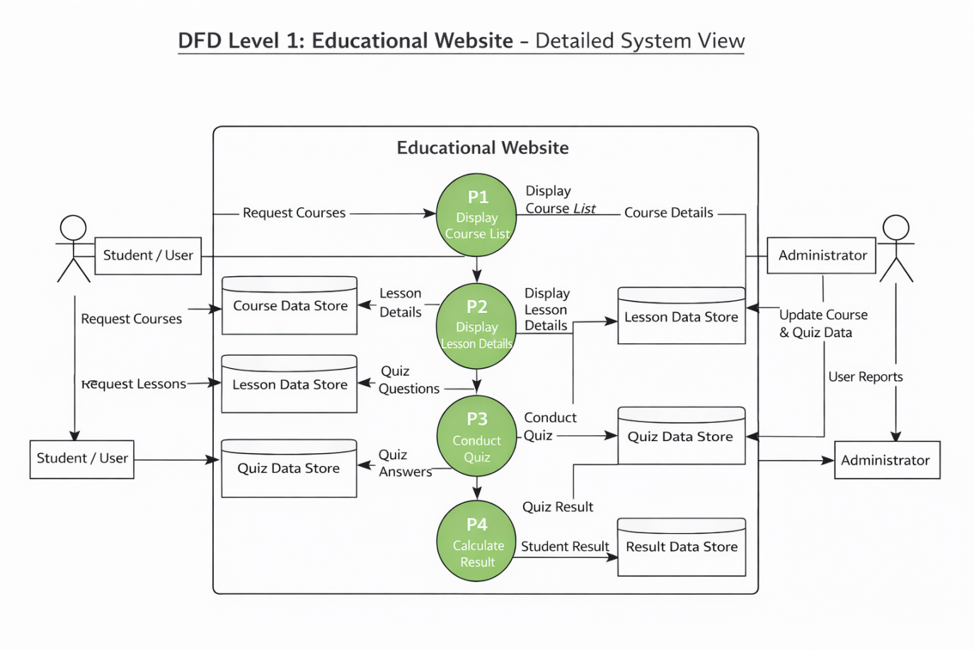
Explanation:
- Process P1:
Retrieves certificate details from the Certificate Data Store.
- Process P2:
Displays certificate records to the user in table format.
- Process P3:
Handles user actions like adding and deleting certificate data.
- Process P4:
Validates input and updates the Certificate Data Store accordingly.
Level 2: Quiz Process (Example Sub-process)
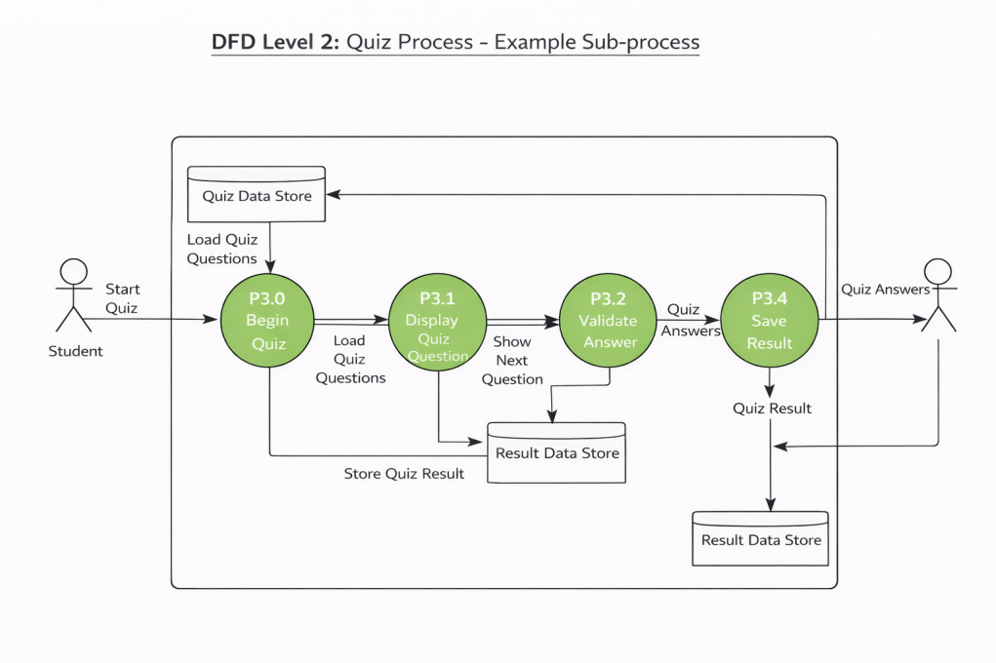
6. Tools to Draw Your DFD

Free, easy online tools:
- https://app.diagrams.net (recommended)
- Lucidchart
- Creately
- StarUML
- Microsoft Visio

📄 STEPS (Using draw.io):
- Go to https://app.diagrams.net
- Choose Blank Diagram → name it “DFD_CertificateManagementSystem”
- Use:
  - Rounded rectangles → Processes (Add, View, Delete)
  - Parallel lines → Data Store (Certificate Data)
  - Rectangles → External Entities (User, Admin)
  - Arrows → Data Flow
- Label all arrows clearly (e.g., “Certificate Details”, “Display Data”)
- Arrange neatly and maintain proper flow (Input → Process → Output)
- Export as PNG/JPG and insert into your report
3.5 Entity Relationship Diagram (ERD)

Entities and Attributes:
- Certificate (Certificate_ID, Name, Course, Date)
- User (User_ID, Name, Role)
- Admin (Admin_ID, Name)

Relationships:
- A User can add multiple Certificates
- An Admin can manage (view/delete) multiple Certificates
- Each Certificate belongs to one User
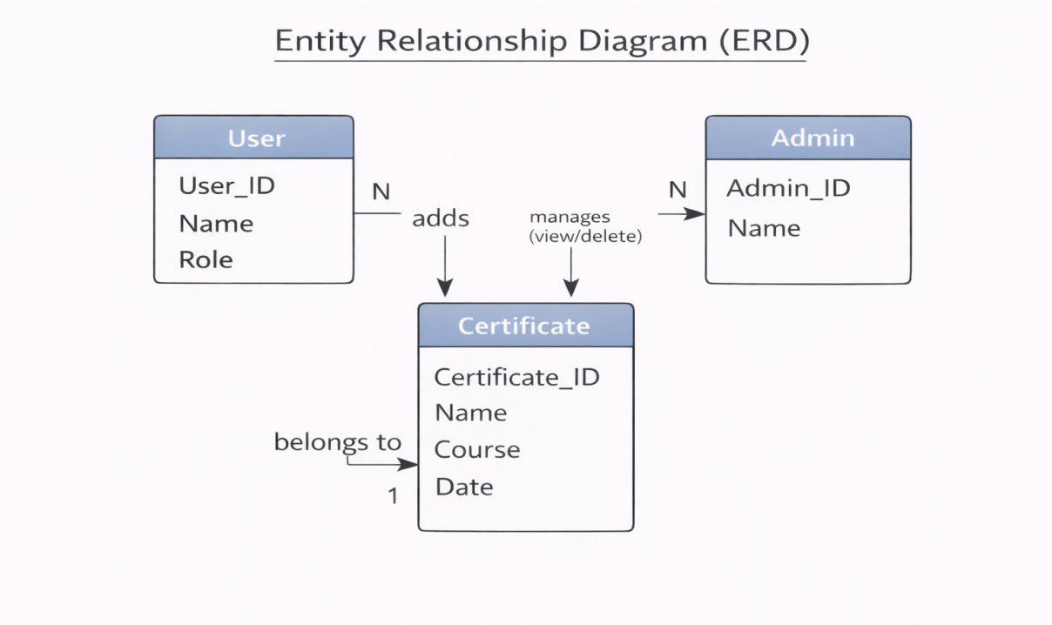

3.6 User Interface Design
The user interface is designed to be simple, responsive, and easy to use. It is developed using React, HTML, CSS, and JavaScript to provide smooth interaction and clear display of certificate data.

Main Pages:
- Home Page:
Displays the title of the Certificate Management System and input form to enter certificate details.
- Add Certificate Section:
Allows users to input student name, course, date, and certificate ID with an “Add Certificate” button.
- Certificate List Page:
Displays all added certificates in a table format with proper columns.
- Delete Functionality:
Provides a delete button for each record to remove unwanted certificate data

Chapter 4: System Implementation
4.1 Introduction
System implementation is the phase where the design of the Certificate Management System is converted into a working application. This stage involves coding, integrating different components, and testing the system to ensure it functions correctly.
The Certificate Management System is implemented using front-end technologies such as React, HTML, CSS, and JavaScript. These technologies help in creating a responsive and interactive user interface. The system allows users to add, view, and delete certificate records efficiently, ensuring smooth performance and better user experience.
4.2 Development Tools and Technologies
Tool / Technology | Purpose
HTML5 | Defines the structure of the user interface
CSS3 / Bootstrap | Provides styling, layout, and responsiveness
JavaScript (ES6) | Handles interactivity and dynamic data updates
Visual Studio Code | Code editor for development and testing
Browser (Chrome / Edge) | Used to run and debug the application
LocalStorage / JSON | Stores and manages certificate data temporarily
4.3 System Modules Description
Module | Description
Home Module | Displays the main page with the system title and certificate input form
Lesson Module | Allows users to enter and submit certificate details
Quiz Module | Shows all added certificates in a structured table format
Result Module | Enables users to remove unwanted certificate records
Feedback Module (Optional) | Checks input fields before adding data to ensure accuracy
Each module is connected through React functions and state management, ensuring smooth data handling and dynamic UI updates within the application.
4.4 Implementation Details
The implementation follows a modular and component-based approach:
- Frontend Design:
The user interface is developed using React with HTML structure and CSS for styling to create a clean and responsive layout.
- Dynamic Behavior:
React dynamically updates the UI using state management (useState) to display certificate data without reloading the page.
- Event Handling:
User actions such as adding and deleting certificates are handled using event functions like onClick and onChange.
- Data Processing Logic:
Functions like addCertificate() and deleteCertificate() manage data operations, while validation ensures all input fields are correctly filled.
- Data Management:
Certificate data is stored temporarily in React state
4.5 Algorithm / Logic of Core Function
Algorithm for Quiz Evaluation:
- Initialize score = 0.
- Loop through all quiz questions.
- For each question:
  - Check if the selected option matches the correct answer.
  - If yes, increment the score.
- Display the total score at the end.
- Store results locally (optional).
Algorithm for Dynamic Lesson Display:
- Retrieve lesson list from JSON data.
- Loop through all lessons.
- Use DOM manipulation (document.createElement(), appendChild()) to render lesson titles.
- Display corresponding lesson content when a user clicks on a title.
4.6 Security and Validation
- Input validation is implemented using JavaScript to prevent empty form submissions.
- Only valid quiz responses are processed.
- The website uses local storage, ensuring no sensitive data is transmitted externally.
- Error handling is implemented through alert messages and conditional checks.
4.7 Integration
All modules are seamlessly integrated using event-driven programming. Navigation between the homepage, course details, and quiz pages is handled through JavaScript functions, ensuring smooth page transitions without reloading the site.
4.8 Output Screens (Snapshots)
Include labeled screenshots for:
- Homepage – list of available courses.
- Lesson Page – lesson titles and content.
- Quiz Page – interactive quiz form.
- Result Page – displayed score and feedback.

Chapter 5: System Testing
5.1 Introduction
System testing is a crucial phase that ensures the developed application meets all functional and non-functional requirements. It validates whether the system performs as expected under various conditions. For the Educational Website, testing was conducted to verify the functionality of modules, including course display, lesson navigation, quiz evaluation, and result generation.
5.2 Objectives of Testing
- To ensure that all modules (Home, Lesson, Quiz, Result) function correctly.
- To identify and fix any logical or runtime errors in the system.
- To confirm that user inputs produce the correct and expected outputs.
- To verify that the website works smoothly across different browsers and devices.
5.3 Types of Testing Performed
a) Unit Testing
Each JavaScript function and webpage component was tested independently. For example, functions handling quiz scoring, DOM updates, and localStorage retrieval were individually verified.
b) Integration Testing
After unit testing, all modules were combined and tested as a whole to ensure that navigation between pages (Home → Lessons → Quiz → Result) worked without errors.
c) System Testing
The complete web application was tested to ensure all functional requirements were met — including quiz evaluations, course listings, and responsiveness.
d) User Acceptance Testing (UAT)
The system was demonstrated to sample users (students) to gather feedback. The website’s layout, speed, and usability were reviewed, and suggestions were implemented where necessary.
e) Cross-Browser and Device Testing
The system was tested on popular browsers such as Google Chrome, Mozilla Firefox, and Microsoft Edge, and on devices like laptops, tablets, and mobile phones to ensure responsiveness.
5.4 Test Plan
Test ID | Module | Test Description | Type | Expected Output | Status
T01 | Home | Display all available courses | Functional | Course cards visible | Pass
T02 | Lesson | Load lesson contents | Functional | Lesson text and videos appear correctly | Pass
T03 | Quiz | Evaluate answers and calculate score | Logic | Correct score displayed | Pass
T04 | Result | Display score summary | Output | Accurate score shown in pop-up | Pass
T05 | Navigation | Move between modules | Integration | Seamless page transition | Pass
T06 | Input Validation | Submit blank quiz | Validation | Show alert or prevent submission | Pass
T07 | Responsiveness | View on mobile devices | UI | Layout adjusts to screen size | Pass
T08 | Storage | Save progress in localStorage | Data | Data retained after refresh | Pass
5.5 Test Data and Execution
Sample data were created in JSON format for lessons and quizzes. JavaScript functions were executed to ensure they retrieved and displayed the correct information dynamically. The output was verified by comparing expected and actual results.
5.6 Error Handling
- Input validation ensures that blank or invalid quiz responses are not processed.
- Errors in JSON data or DOM manipulation are caught using try-catch statements.
- Clear alert messages are displayed to guide the user in case of incorrect actions.
5.7 Performance and Usability Testing
- Performance: Page load time was under 2 seconds in standard browsers.
- Usability: Students found the website easy to navigate, visually clear, and responsive.
- Accessibility: The system supports keyboard navigation and uses readable font styles for better visibility.
5.8 Results and Observations
All modules functioned as expected. The website performed well on multiple devices, and user feedback confirmed that it was interactive and efficient. No critical defects were identified in the final round of testing.

Chapter 6: Results and Discussion
6.1 Introduction
This chapter presents the practical results obtained after implementation and testing. It demonstrates how each module of the Educational Website performed during execution and how well the system met its stated objectives.
6.2 System Outputs
During execution, the system produced the following key results:
- Homepage: Displayed a list of courses with titles and short descriptions.
- Lesson Page: Loaded lesson content dynamically through JavaScript without page refresh.
- Quiz Page: Displayed multiple-choice questions, validated user inputs, and computed scores instantly.
- Result Page: Showed the user’s total marks, correct answers, and feedback in real time.
All pages were verified to be responsive and accessible across desktop and mobile browsers.
6.3 Performance Analysis
- Responsiveness: Average page load time < 2 seconds.
- Accuracy: Quiz scoring achieved 100 % logical accuracy.
- Stability: No runtime or data-handling errors during repeated trials.
- Cross-Browser Compatibility: Verified on Chrome, Edge, and Firefox with consistent results.
6.4 User Feedback
A small group of student users tested the prototype. Feedback indicated:
- Simple and intuitive navigation.
- Readable layout and clear quiz interface.
- Desire for additional courses and login functionality in future versions.

Chapter 7: Conclusion and Future Enhancement
7.1 Conclusion
The Educational Website project successfully demonstrates how modern web technologies can be applied to create an interactive and accessible learning platform. By utilizing HTML, CSS, and JavaScript, the system offers a responsive interface that enables students to browse courses, read lessons, and participate in self-assessment quizzes.
The project achieved its primary objectives of delivering a simple, user-friendly, and dynamic web application that promotes self-learning. Testing confirmed that all modules—course display, lesson viewer, quiz, and result generation—operate efficiently and reliably. The system meets functional and non-functional requirements such as usability, portability, and responsiveness.
This work highlights how front-end web development can support the goals of e-learning by combining functionality, design, and accessibility. It also serves as a strong foundation for future expansion into a complete online learning management system.
7.2 Limitations
While the system meets its core goals, the current version has a few limitations:
- No user authentication or database integration.
- Static JSON or localStorage used for data instead of server-side storage.
- No multimedia uploads or video streaming options.
- Limited analytics or tracking of user progress.
7.3 Future Enhancement
The project can be enhanced and scaled in several ways:
- Database Integration: Connect to MySQL or MongoDB for storing user data, courses, and quiz results.
- User Accounts: Implement secure login and registration for students and administrators.
- Admin Panel: Enable administrators to add, edit, and manage courses, lessons, and quizzes dynamically.
- Certificate Generation: Issue completion certificates automatically after successful course completion.
- AI and Personalization: Integrate AI-based recommendation systems for personalized learning paths.
- Cloud Deployment: Host on cloud platforms (e.g., AWS, Firebase) for multi-user access and real-time updates.
- Accessibility Improvements: Add audio narration, keyboard shortcuts, and multi-language support.

Chapter 8: References
8.1 Books & Journals
- Web Technologies: HTML, CSS, JavaScript, PHP, Java, JSP, XML, and AJAX — Uttam K. Roy, Oxford University Press.
- Learning Web Design — Jennifer Niederst Robbins, O’Reilly Media.
- E-Learning and the Science of Instruction — Ruth C. Clark & Richard E. Mayer, Wiley.
8.2 Online Resources
- MDN Web Docs — https://developer.mozilla.org
- W3Schools — https://www.w3schools.com
- Bootstrap Official Documentation — https://getbootstrap.com
- JavaScript.info Tutorials — https://javascript.info
- FreeCodeCamp Tutorials — https://www.freecodecamp.org
- GeeksforGeeks Web Development Articles — https://www.geeksforgeeks.org
8.3 Tools & Frameworks Used
- Editor: Visual Studio Code
- Languages: HTML5, CSS3, JavaScript (ES6)
- Framework: Bootstrap 5 (for responsive UI)
- Database (Future Scope): JSON / MySQL
- Browser: Google Chrome / Microsoft Edge

Appendices
Appendix A – Source Code
Include your main source files:
- index.html — Homepage and structure.
- style.css — Styles and responsive layout.
- script.js — Core logic for lessons, quizzes, and interactivity.
(Attach or paste formatted source code snippets here — only essential parts, not full-length code, to maintain report readability.)
Appendix B – Screenshots of Web Pages
Attach labeled screenshots with captions:
- Figure 1.1: Homepage displaying available courses.
- Figure 1.2: Lesson Viewer interface.
- Figure 1.3: Quiz Page with active questions.
- Figure 1.4: Result Page showing user score and feedback.
- Figure 1.5: Responsive view on mobile devices.
(Ensure all figures are captioned and referenced in your text, e.g., “Refer to Figure 1.3”).
Appendix C – User Manual / Installation Guide
Steps to Run the Project:
- Download all project files (index.html, style.css, script.js).
- Place them in the same folder.
- Open index.html in any modern browser (Chrome, Firefox, Edge).
- Browse courses, read lessons, and attempt quizzes.
- Check your result displayed instantly on the page.
System Requirements:
- OS: Windows / macOS / Linux
- Browser: Latest Chrome or Firefox
- RAM: Minimum 2 GB
- Storage: 100 MB free

